BookMarkManager 2.1 Shareware Version
Author: Edgar M. Hofer
email: Edgar-Hofer@msn.com

With this tool you can convert your
MS-IEXPLORER-FAVORITES to NS-NAVIGATOR-BOOKMARKS
and VICE-VERSA !!

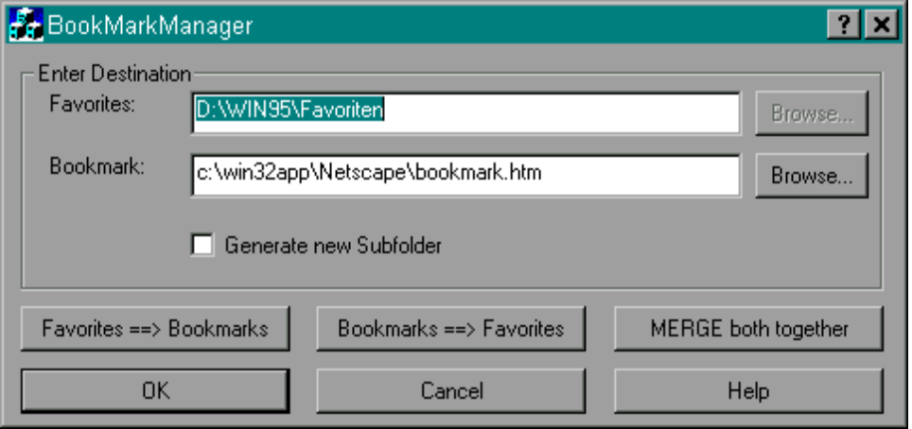

Installation:
There is no extra setup, copy the files from the zip to any place you want and simply start the exe-file or make links of your choice. If you miss a fine setup-code (making icons - where YOU will move it away - and so on...), remember:
You saved very much time for not downloading my setup-stuff <bg>

Release Notes - Version 2.1:
Some Bugfix for correct reading of „bookmark.htm“-File. (Special Characters like Slash or Backslash will be converted to: ! )

Converting-Special Options
a) Generate new Subfolder
If you choose this, the destination will NOT be overwritten. Instead the hole source will be inserted in the destination as a new branch.

b) MERGE both together
This will UPDATE BOTH (NS-Navigator and MS-IExplorer) with the unique links of each other. After choosing this function, you will have the same, merged URLs in your Bookmarks and in your Favorites.

Registering:
Please look in „register.doc". Please use Albert’s Ambry Online-Registration-Service via the Internet. You can use the unregistered Software only 10 times before it is disabled!

Updates/Support:
http://ourworld.compuserve.com/homepages/Edgar_Hofer/BookMM.htm

Copyright-Notice: The hole ZIP-File can be published free and without any notification via BBS, Online-Services, Internet, CD-Producer, Book-Applets or what- and however you want!

